GEETHA RAJ
(+91) 6303567101 | rajchinnamsetty@gmail.com

CAREER OBJECTIVE
Enthusiastic Computer Science graduate specializing in Data Science and Web developer, seeking to apply my technical skills and passion for data-driven solutions in a dynamic organization. Eager to contribute to impactful projects and grow in a collaborative environment.

EDUCATION
KL UNIVERSITY HYDERABAD
B.Tech in Computer Science and Engineering |CGPA: 9.3  St.Patrick’s junior college, Nallakunta | Aug 2023 - May 2027
Class XII | Percentage: 95%  St.Ann’s Girls High the school , Masab Tank | Apr 2023
Class X | GPA: 10.0 | Mar 2021

PROJECTS
Automatic Car parking system (using java and react js) | GitHub
A Ping Pong Game using GUI in python

TECHNICAL SKILLS
- Languages: Java, Python, C, SQL, HTML, JavaScript,ReactJs, NextJs, MongoDB
- Tools and Technologies: Tableau, Excel, DBMS, TensorFlow, Power bi, Flutter Flow, QlikSense,Git and GitHub
- Databases: MySQL, Convex, Prisma

CERTIFICATIONS
- Certified in MongoDB Database Admin Path
- Certified in Spring Essentials by Infosys
- Certified in Data Structure & Algorithms in Java for Intermediate Level

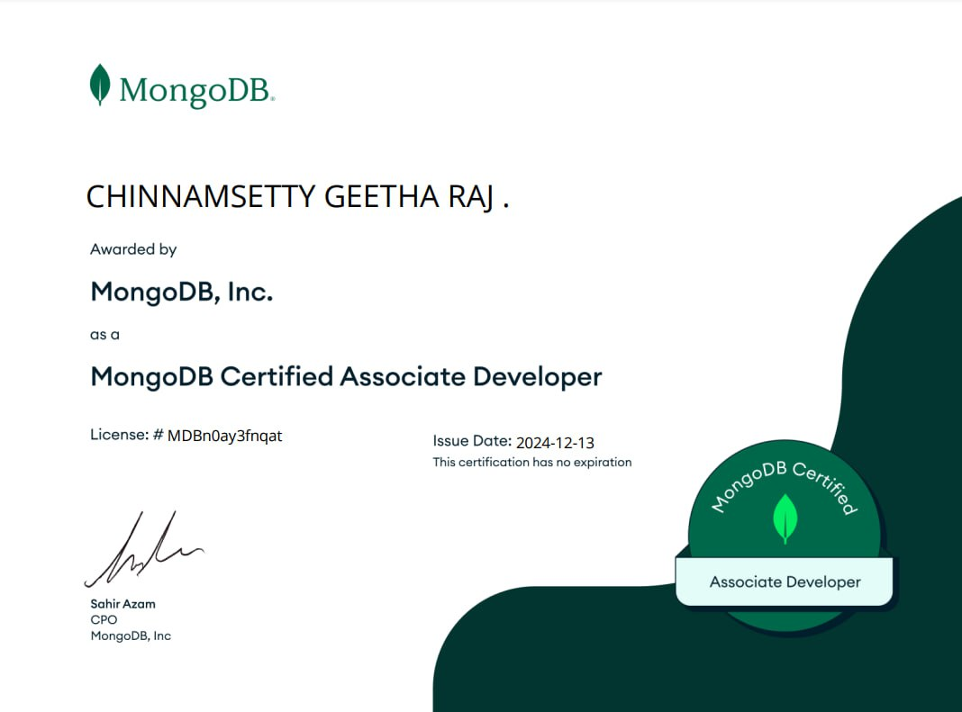
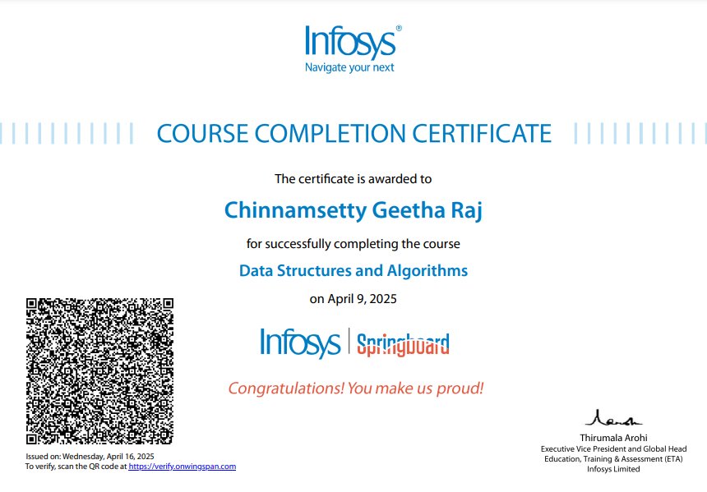

DECLARATION
I hereby declare that all the above-mentioned information is true and correct to the best of my knowledge. j

